***Chapter-8***

**Screen shots and User manual**



**Register form : user can fil the information to the register**

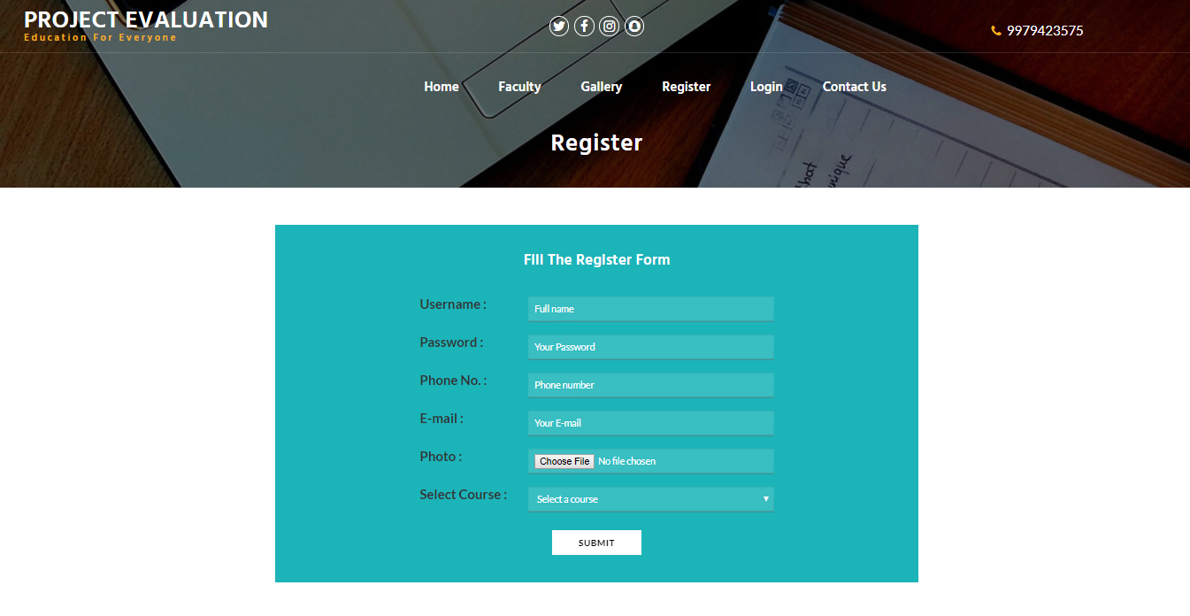

**Login form : user can fil the information to the login form and then after to the user can perform to the practical.**

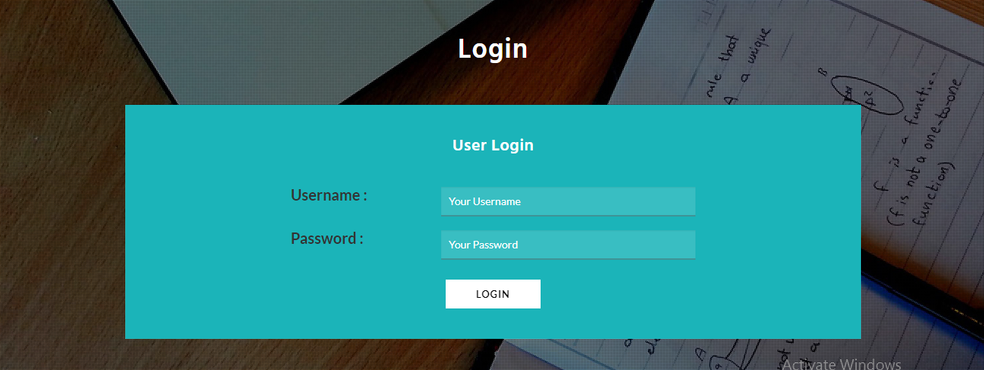

**Editior : user can perform the practical**

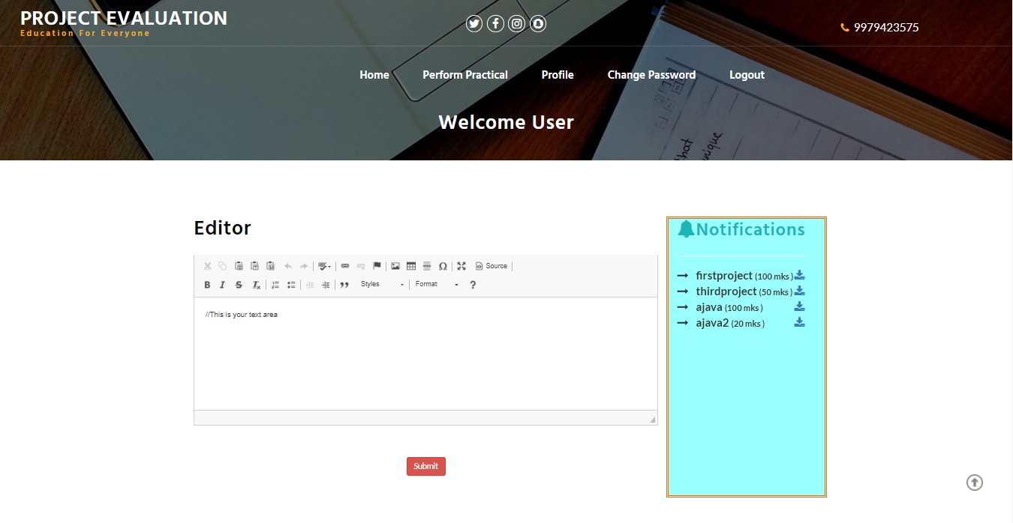

**Userprofile : after login and details of the user.**

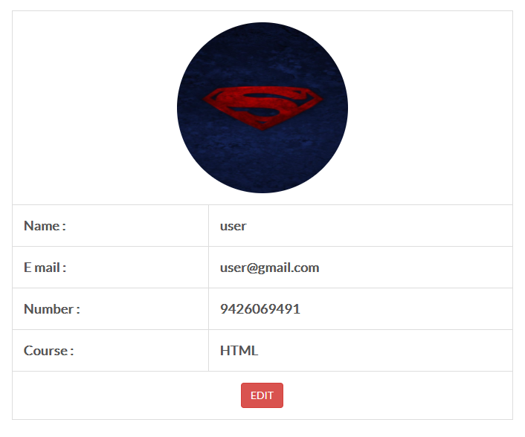

**Change password: user can change the password**



**Admin Login**

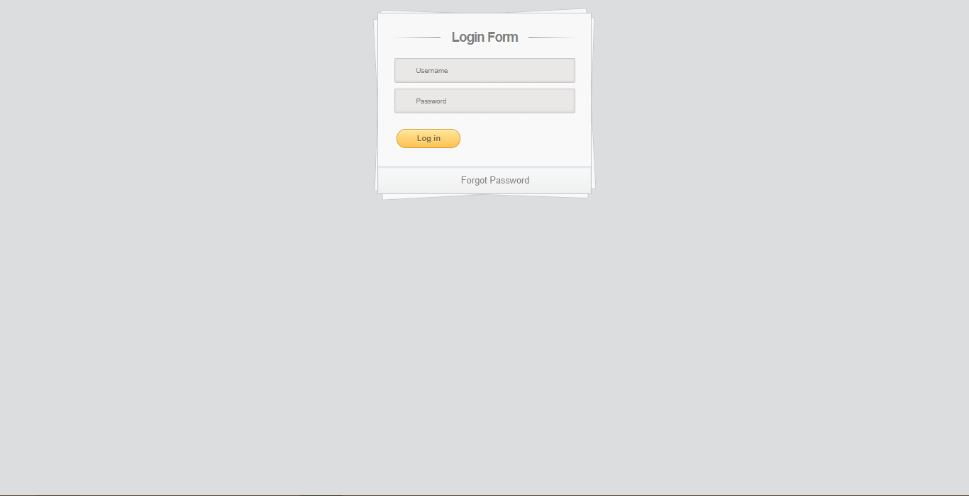

**Admin Panel-🡪User Table**

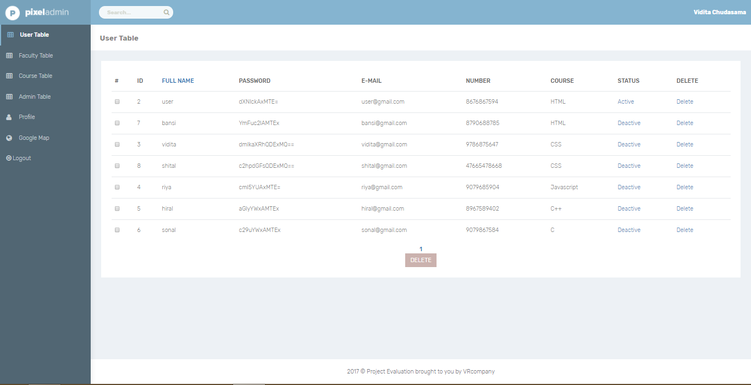

**Admin-🡪faculty**

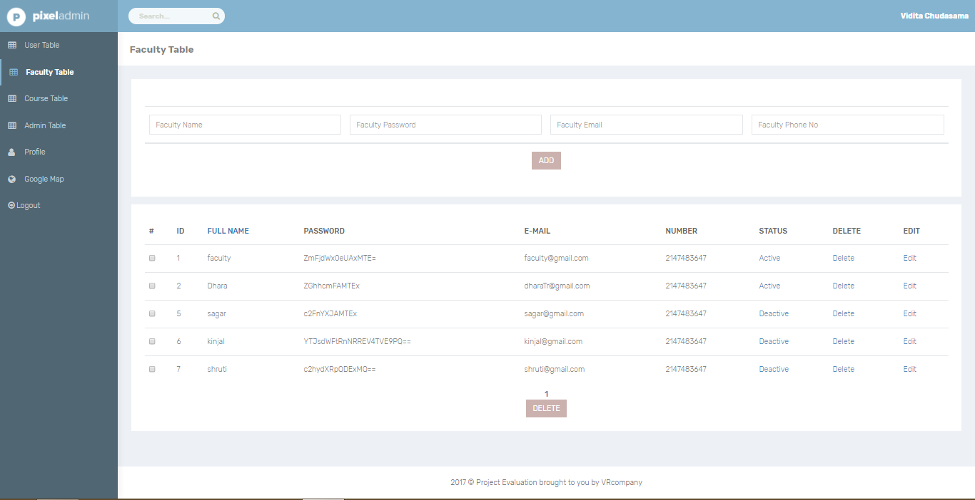

**Course Table**

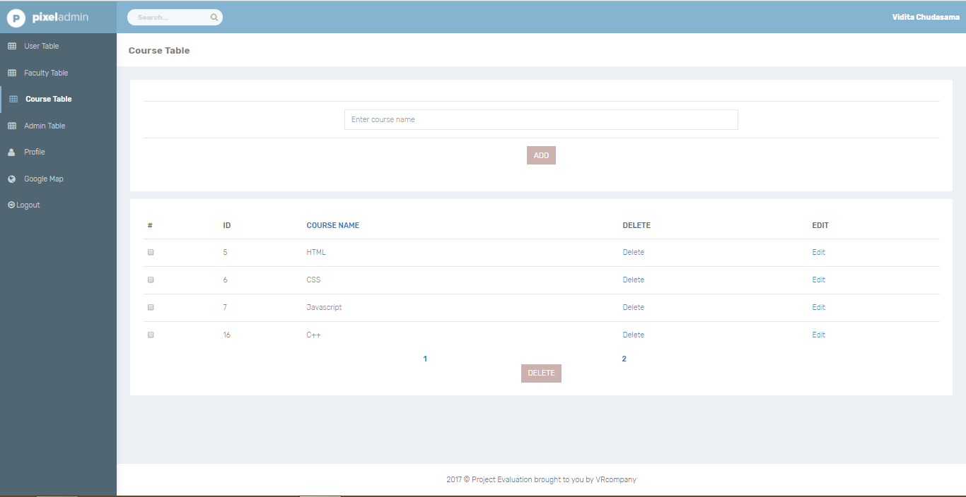

**Profile page**

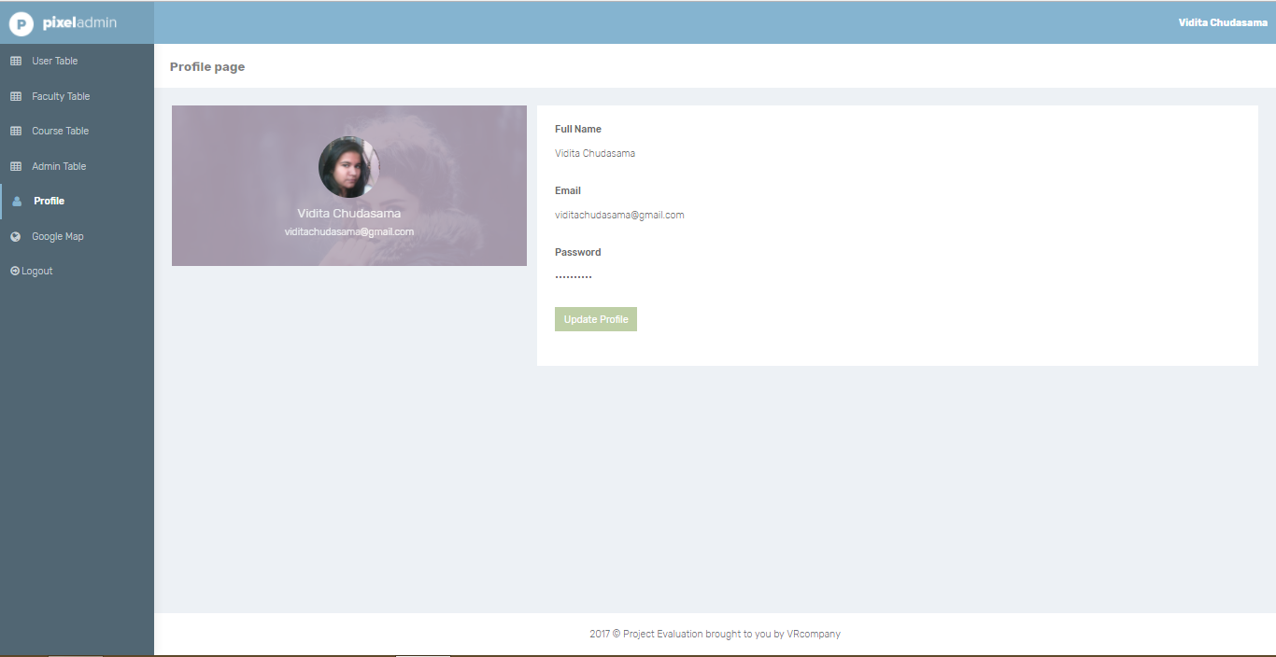

**Faculty: faculty can fil the information to the login form and then after faculty can send definition to the student.**

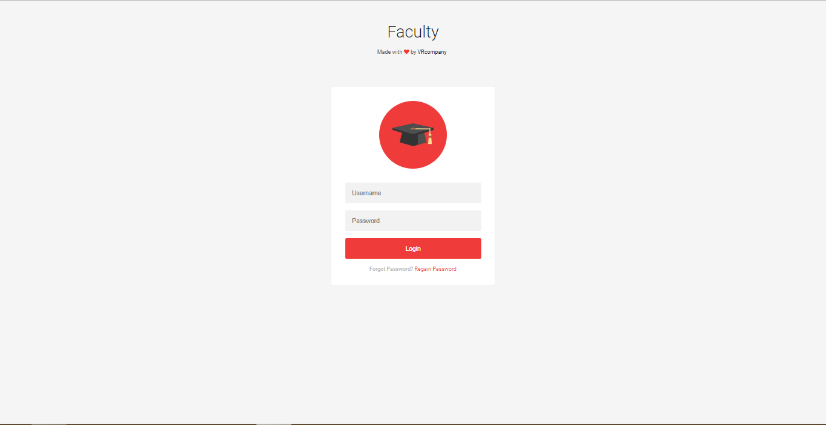

**Faculty header: after the login form they can send the practical.**

